OPERATING SYSTEMS
INTRODUCTION TO OS

(Relevance of Operating System)
1. You must have interacted with the operating systems when working on your laptop or mobile phones like windows, Mac OS, Android, iOS etc.
Think of a common scenario of copying a file and pasting the contents to another file in your computer system. Do you think operating systems play any role in performing this task? If yes, explain how operating systems do that.
Moreover, use this opportunity to think of more situations in which operating systems play a key role.

(Mapping of Computer Hardware)
2. The example of the manager and the restaurant is made analogous to the operating system and computer system. Users are correctly mapped to customers, Waiters are correctly mapped to applications and the manager of the restaurant is mapped to the operating system. All the other resources in the kitchen of the restaurant are mapped to hardware resources of the computer system.

Can you match the following hardware resources to their appropriate counterpart in the kitchen of a restaurant?

Hardware resources | Resources in kitchen of a restaurant
1. CPU of the computer | a. Countertop
2. Main Memory or RAM | b. Cupboard
3. Disk | c. Chef at the restaurant

Note: Countertop or kitchen bench is the horizontal bench where the chef keeps all his required vegetables and equipment to prepare the food.
a) 1 - c, 2 - a, 3 – b b) 1 - c, 2 - b, 3 - a
c) 1 - b, 2 - a, 3 – c d) 1 - a, 2 - b, 3 - c

(Composition of Operating System)
3. From the analogy explained in the lecture video, it is clear that the OS acts as an interface between applications and hardware and the users interact with applications to get their tasks done. This diagram explains the interface between various actors in our discussion:

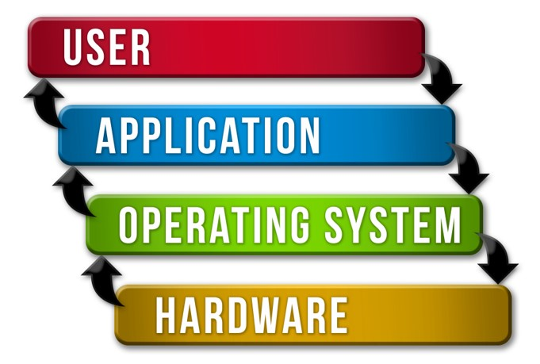

According to you, what is an operating system made of?
a) Collection of hardware components b) Collection of input-output devices
c) Collection of software functions d) All the above

(Removal of Operating System)
4. What will happen if you remove the operating system from the following diagram?

(Code Sharing by OS)
5. Let us rephrase a function of OS.

There are certain tasks that repeatedly performed by the applications, such as writing contents to a storage location on Hard Disk. Now, OS writes the code of this task at one place and let all the applications use this code. This code sharing feature saves application from writing the same code again and again in their source code.

Which of the following functions of OS does this code sharing feature map to?
a) OS acts as an interface between applications and hardware
b) OS acts as a resource manager
c) OS hides the hardware complexity
d) OS makes it easier for user to use the hardware.

(Choose the correct option)
6. Choose the correct function of OS for the following example:

Example: A user using different vendors of speakers on the same computer system.
a) Arbitration b) Abstraction
c) Abstraction as well as arbitration

(Choose the correct option)
7. Choose the correct function of OS for the following example:

Example: Interchangeable access to hard disk and SSD disk.
a) Arbitration b) Abstraction as well as arbitration
c) Abstraction

(Choose the correct option)
8. Choose the correct function of OS for the following example:

Example: A user using pen digitizer to write on the screen of the computer system.
a) Arbitration b) Abstraction
c) Abstraction as well as arbitration

(Similar Examples)
9. Look at the following tasks done by the OS:

1. The distribution of memory among different applications
2. Different applications running on the computer system

These examples were explained in the lecture video. In both of these examples, OS was doing abstraction as well as arbitration.
How are these two examples different from each other? Also, can you justify the functions of the OS in these examples?

(Primary Use of Operating System)
10. Which of the following choices best describes the functions of an operating system?
a) To make the most efficient use of computer hardware
b) To allow people to use the computer
c) To keep system programmers employed
d) To make it difficult for layman users to damage the computer system

(Components of Operating System)
11. Which of the following are the parts of the kernel of an operating system:
a) File manager b) File editor c) Cache memory
d) I/O manager e) Web browser f) Process manager

(Kernel Functionalities)
12. If you have to copy the contents of a file called "cn.txt" in one of your folders to another folder. Assume the name of file in another folder is "cncopy.txt".

To complete this process, OS first reads all the contents from "cn.txt" and stores it into the memory and then OS writes all the contents to "cncopy.txt".

Match the following tasks to the appropriate kernel functionality involved in it:

Task | Functionality
1. Reading the contents of a file | a. Memory Management
2. Copying the file contents into the memory | b. Process Management
3. Whole process of copying and pasting the contents of file | c. File Management

a) 1-a, 2-b, 3-c b) 1-b, 2-c, 3-a
c) 1-b, 2-a, 3-c d) 1-c, 2-a, 3-b

(Hybrid Kernel)
13. Why do you think the Hybrid kernel has better performance than Microkernel and small size in comparison to the Monolithic kernel?

Diagram for your reference:

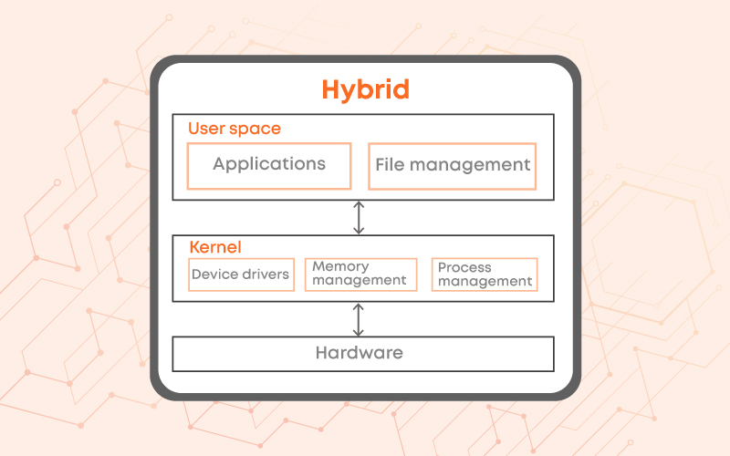

(System Calls)
14. System calls are invoked by using:
a) A software interrupt b) Polling
c) An indirect jump d) A privileged instruction

(Match the following)
15. Match the following for system calls listed in List-1 with appropriate

List-1 | List-2
a. exec() | 1. Creates a new process
b. exit() | 2. Keeps the process id same and replaces the running code with a new code
c. wait() | 3. Terminates a running process properly
d. fork() | 4. A process synchronizes with termination of child process

a) (a) - 2, (b) - 3, (c) - 4, (d) – 1 b) (a) - 2, (b) - 3, (c) - 1, (d) - 4
c) (a) - 3, (b) - 2, (c) - 4, (d) – 1 d) (a) - 4, (b) - 2, (c) - 1, (d) - 3

(Commands Exploration)
16. Let's say you have a process running on your system with process id 3851.
Now, you have to run the following commands in Bracket - 1 and match them to their appropriate outputs in Bracket – 2

Bracket - 1 | Bracket - 2
1. kill 3851 | a. Passes a keyboard interrupt to the running process
2. kill -9 3851 | b. Abruptly terminates the running process
3. kill -2 3851 | c. Properly terminates the running process
4. kill -l | d. Lists all the available signals that can be passed to kill command

a) 1 - c, 2 - d, 3 - a, 4 – b b) 1 - c, 2 - b, 3 - a, 4 - d
c) 1 - a, 2 - b, 3 - c, 4 – d d) 1 - c, 2 - a, 3 - b, 4 - d

(Information Management Calls)
17. Functions of some of the information management calls or system calls are listed below.

1. System call to find data and time of the system
2. Call to find free space on the disk
3. System call to find allocated and free memory

These system calls have wrapper terminal commands as well.

Explore the internet to find these wrapper commands.

(Choose the correct option)
18. Choose the correct statements in relation to system calls and commands of the terminal?
a) Operating systems are mostly implemented in C. System calls are function calls to implementations of functions where they interact with hardware resources.
b) Terminal commands are a wrapper over the system calls. Behind the scenes of terminal commands are function calls to the system calls.
c) System calls are used to interact with the kernel of Operating systems.
d) All the above statements are correct.

(Commands Exploration)
19. As you have installed the Linux OS on your system, you have tried the commands explained in the lecture video on the terminal and you have explored the man pages of various commands, as explained in the note.

Let us try out a few more commands. Before trying these commands, create two files in the home folder by using using following command: cat >newfile.txt

After writing this command, the prompt will not be returned back to you, after pressing enter key. So, whatever you will write on the terminal, it will become the contents of your file: newfile.txt. So, let’s write “Welcome to Coding Ninjas Operating Systems Course” and press Ctrl + C to terminate the process of writing to this file. Similarly, create another file with the name “anotherfile.txt” and write “Let’s try out some commands” in it.

Now, you have to run the following commands in Bracket - 1 and match them to their appropriate outputs in Bracket – 2

Bracket - 1 | Bracket - 2
1. cat newfile.txt | a. It will append the contents of one file to another
2. cat newfile.txt anotherfile.txt | b. It will show content of a file with line number
3. cat -n newfile.txt | c. It will show the contents of both newfile.txt and anotherfile.txt
4. cat newfile.txt >> anotherfile.txt | d. It will show the contents of newfile.txt

a) 1 - a, 2 - c, 3 - b, 4 – d b) 1 - d, 2 - c, 3 - b, 4 - a
c) 1 - d, 2 - b, 3 - c, 4 – a d) 1 - a, 2 - b, 3 - c, 4 - d

(Choose the correct option)
20. Select the correct definition for abstraction, mechanism and policies
a) Abstraction includes OS’s abstracted form of application as well as hardware resources, mechanism is how to do something and policies are what will be done
b) Abstraction includes OS’s abstracted form of hardware resources, mechanism is what will be done and policies are how to do something
c) Abstraction includes OS’s abstracted form of hardware resources, mechanism is how to do something and policies are what will be done
d) Abstraction includes OS’s abstracted form of application as well as hardware resources, mechanism is what will be done and policies are how to do something

**********

